1. Install nginx and run nginx on port number 81.

yum update -y

yum install nginx -y

systemctl enable nginx

systemctl start nginx

systemctl status nginx



To view the nginx default page from the terminal :

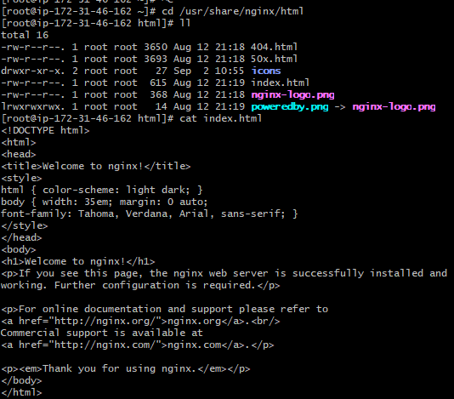

To configure the port:

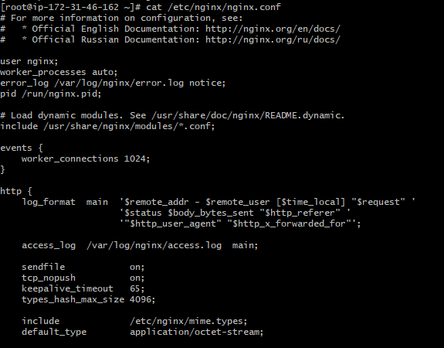





2) Deploy a sample index.html file on nginx.

Cd /usr/share/nginx/html/



3 ) Install Apache and run Apache on port number 82



4) Deploy a sample index.html file on Apache.





5) Install Apache tomcat on port number 8082

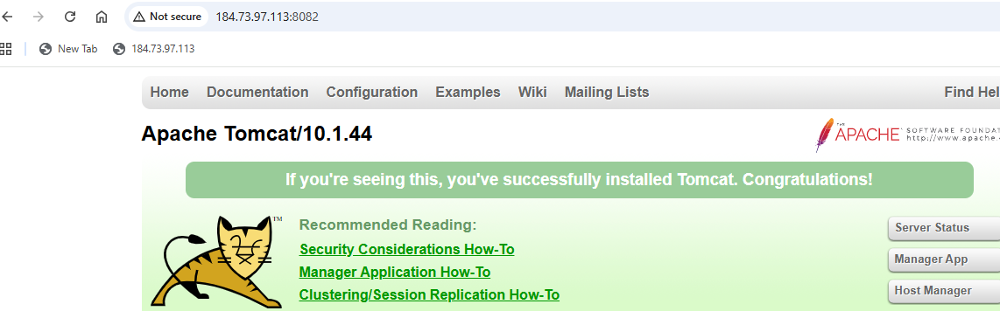

6) Deploy a sample app on webapps

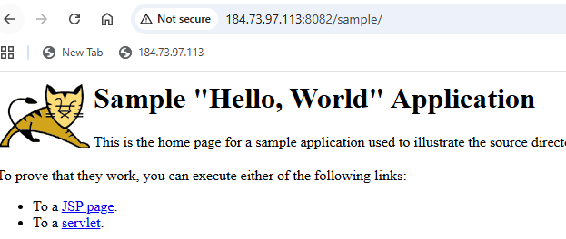

7) Create a tomcat.service file for tomcat.

Open/Create the service file:

vi /etc/systemd/system/tomcat.service

Paste this content:

[Unit]

Description=Apache Tomcat Web Application Container

After=network.target

[Service]

Type=forking

User=tomcat

Group=tomcat

Save and Exit:

:wq!

Reload system:

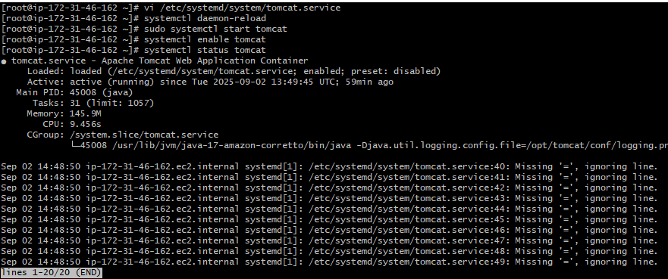

8) Configure HA Proxy server

deploy a httpd server  
deploy a nginx server  
deploy a tomcat server  
install a HAPROXY server  
yum install haproxy  
systemctl enable haproxy  
cat /etc/hosts (edit file and paste public ips of two servers with names httpdserver1:public ip nginxserver:public ip)  
:wq!  
vi /etc/haproxy/haproxy.cfg (paste public ips with port 80 extension of two servers also change listen port to 80)  
systemctl restart haproxy  
systemctl status haproxy



